DIGITAL MARKETING

Assignment 4 – Creating a email newsletter and posting it in blog

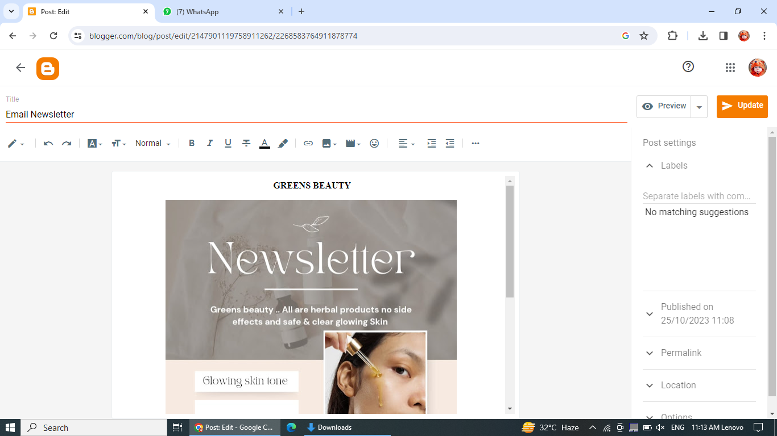

Email newsletter link :

<https://www.blogger.com/blog/post/edit/2147901119758911262/2268583764911878774>

Email newsletter

